Introduction of chemicals

Please fill out this form and send it to nanolab@ntnu.no

All personal chemicals must be accepted and labelled with your activity number on a special sticker before they are taken into the cleanroom. You get this sticker when your chemical is accepted. Chemical flasks without such a sticker can be removed from the cleanroom without warning.

Form filled out by:
Date | Name
List the NanoLab activity numbers the chemical will be used in: NL

Information about the product:
Name of the chemical
Attach SDS as .pdf to mail or link below, both in English and Norwegian:

CAS-number
Unique numerical identifyer
Company name of supplier
Product number
Amount
Strength/ purity
Other:

Information about location:
Storage requirements:

See safety data sheet (SDS),
Head 7 for guidance, write in your own words.
Will be used and stored in  Identify both room and chemical cabinet at NTNU NanoLab. Click on “choose storage place” to select cabinet  Other (e.g. desiccator): | Area for chemical methods.  Area for characterisation and bionanotechnological methods (ISO 7).  Area for physical methods (ISO 5+6).

Information about substitution:
For hazardous chemicals you are obligated to make an assessment as to whether it can be replaced/ substituted by another, less hazardous, chemical or substance.

Is there any less hazardous chemical you could use instead? | Yes, there is  No, there is not | Comment:

Information about exposure and time-frame for use of the chemical:
Frequency
Comments:
How open is your system?  If you use multiple, choose the one with highest risk of exposure. | Examples of bench with ventilation  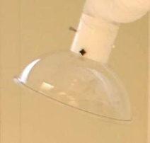  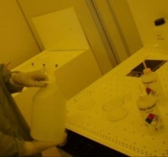  Comments

Information about method of use of the introduced chemical:
Risk assessment of work with/ mixing of chemicals must be submitted separately. | Tick off “Yes” or “No” | Comments:
Degradation due to heat, humidity or air. | Yes No
Heating of liquids | Yes No | State temperature
Dust-producing during process | Yes No
Spin coating | Yes No
Mixing of chemicals | Yes No | Describe the chemical mixture and reaction
Other information:

Here you should mention information about dangerous reactions and/or other properties of the chemical to be aware of.

Information about personal protection equipment:
What personal protection equipment (PPE) are you going to use?
Select and tick off. See safety data sheet (SDS), head 8 for guidance.
Gloves  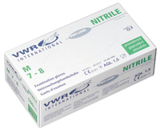  Disposable Nitrile Gloves  Two pair Nitrile Gloves  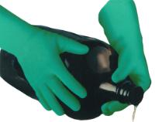  STANSOLV®/A-10CR Solvent Resistant Gloves (nitrile)    TRIONIC 517  Acid Resistant Gloves (nitrile, neoprene and natural rubber) | Eye protection  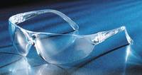  Safety spectacles  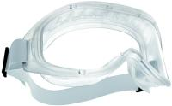  Safety goggles  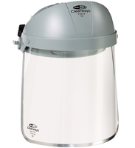  Face Shield | Apron  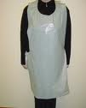  Disposable apron, PE    Protective Apron in nitrile
Other:

Information about disposal of chemical waste:
The component that is most hazardous in your mixture should be prioritized when selecting a waste bottle. (For instance, chemicals mixed with Hydrofluoric acid are always disposed of in the Hydrofluoric acid waste.)

If chemical waste produced within your activity do not fit into any of our categories of waste, this waste must be collected in a separate waste bottle/ box marked with activity number, name, content and warning labels. Examples: biological waste, chemicals that must be disposed of separately. Do not store this waste longer than one month in the NanoLab facilities. Do not store reactive solutions! Remember to test peroxide formers regularly. The user/department of the user is responsible for disposal of this waste.

Other information/ comments:

Which waste bottle are you going to use?
Select and tick off. See safety data sheet (SDS) for guidance.
Category of waste | Examples | Comments | Select and tick off.
Waste water, wash water | Aqueous solution or water contaminated by organic material. | Content of halogen < 0,5%
Waste water, wash water  *with heavy metals or nano materials | Aqueous solution or water contaminated by organic material*. | Content of halogen < 0,5%  Heavy metals: As, Au, Fe, Cu,  Co, Cr, Mn, Ni, Pt, Zn, Ag,Sn…
Non-halogenated organic solvents | - Isopropyl alcohol (IPA, 2-Propanol)  - Acetone - Ethanol  - Heptane - Toluene  - Non-halogenated resists  - Non-halogenated thinners/ removers  - Non-halogenated EBL developers | Content of halogen < 0,5%
Non-halogenated organic solvents *with heavy metals or nano materials | - Acetone* - Ethanol*  - Heptane* - Toluene* - IPA*  - Non-halogenated resists*  - Non-halogenated thinners/ removers*  - Non-halogenated EBL developers* | Content of halogen < 0,5%  Heavy metals: As, Au, Fe, Cu,  Co, Cr, Mn, Ni, Pt, Zn, Ag,Sn...
Halogenated organic solvents | - Solvents containing halogens  (fluorine, chlorine, bromine, iodine).  - PMMA Series resists | Content of halogen > 0,5%
Halogenated organic solvents  *with heavy metals or nano materials | - Solvents containing halogens*  (fluorine, chlorine, bromine, iodine).  - PMMA Series resists* | Content of halogen > 0,5%  Heavy metals: As, Au, Fe, Cu,  Co, Cr, Mn, Ni, Pt, Zn, Ag,Sn…
Organic acids | - Acetic acid  - Citric acid  - Organic solvents mixed with acid
Organic acids  *with heavy metals or nano materials | - Acetic acid*  - Citric acid*  - Organic solvents mixed with acid* | Heavy metals: As, Au, Fe, Cu,  Co, Cr, Mn, Ni, Pt, Zn, Ag,Sn…
Diluted inorganic acids | - Hydrochloric acid - cold RCA-2  - Sulphuric acid - cold Piranha  - Nitric acid  - Phosphoric acid
Diluted inorganic acids  *with heavy metals or nano materials | - Hydrochloric acid* - cold RCA-2*  - Sulphuric acid* - cold Piranha*  - Nitric acid*  - Phosphoric acid* | Heavy metals: As, Au, Fe, Cu,  Co, Cr, Mn, Ni, Pt, Zn, Ag,Sn...
Hydrofluoric acid | Hydrofluoric acid (HF)
Organic bases | - Amines  - Photoresist developers  - Organic solvents mixed with base
Organic bases  *with heavy metals or nano materials | - Amines*  - Photoresist developers*  - Organic solvents mixed with base* | Heavy metals: As, Au, Fe, Cu,  Co, Cr, Mn, Ni, Pt, Zn, Ag,Sn...
Inorganic bases | - cold RCA-1  - Ammonia  - Sodium hydroxide  - Potassium hydroxide
Inorganic bases  *with heavy metals or nano materials | - cold RCA-1*  - Ammonia*  - Sodium hydroxide*  - Potassium hydroxide* | Heavy metals: As, Au, Fe, Cu,  Co, Cr, Mn, Ni, Pt, Zn, Ag,Sn...
Inorganic solid waste  (may include heavy metals or nano materials) | - Inorganic samples (wafers)  - Nano materials (allowed with container)  - Scalpel blades, hypodermic needles  - Contaminated grinding paper  - Other metal containing waste | Heavy metals: As, Au, Fe, Cu,  Co, Cr, Mn, Ni, Pt, Zn, Ag,Sn…

